**Part 84 - Real time example of queue collection class in c#**

Here is one simple **real-time working example where a Queue class can be used**.  
  
When you walk into a bank or a passport office, you will collect a token and wait in the queue for your token number to be called. From the application perspective, when a token is issued, the token number will be added to the end of the Queue. When a representative at the counter is available to server a customer, he will push the "Next" button and the token number that is present at the beginning of the queue, will be dequeued. So, this is one example, where a Queue collection class can be effectively used.

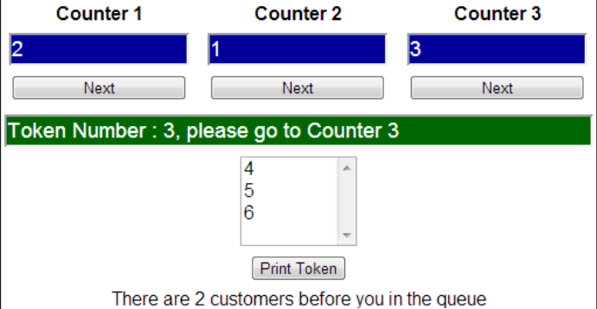

**WebForm1.aspx**  
<table style="border:1px solid black; font-family:Arial; text-align:center">  
    <tr>  
        <td>  
            <b>Counter 1</b>  
        </td>  
        <td>  
            <b>Counter 2</b>  
        </td>  
        <td>  
            <b>Counter 3</b>  
        </td>  
    </tr>  
    <tr>  
        <td>  
            <asp:TextBox ID="txtCounter1" Width="150px" Font-Size="Large" runat="server"  
                            BackColor="#000099" ForeColor="White">  
            </asp:TextBox>  
        </td>  
        <td>  
            <asp:TextBox ID="txtCounter2" Width="150px" Font-Size="Large" runat="server"  
                            BackColor="#000099" ForeColor="White">  
            </asp:TextBox>  
        </td>  
        <td>  
            <asp:TextBox ID="txtCounter3" Width="150px" Font-Size="Large" runat="server"  
                            BackColor="#000099" ForeColor="White">  
            </asp:TextBox>  
        </td>  
    </tr>  
    <tr>  
        <td>  
            <asp:Button ID="btnCounter1" Width="150px" runat="server" Text="Next"   
                onclick="btnCounter1_Click" />  
        </td>  
        <td>  
            <asp:Button ID="btnCounter2" Width="150px" runat="server" Text="Next"   
                onclick="btnCounter2_Click" />  
        </td>  
        <td>  
            <asp:Button ID="btnCounter3" Width="150px" runat="server" Text="Next"   
                onclick="btnCounter3_Click" />  
        </td>  
    </tr>  
    <tr>  
        <td colspan="3">  
            <asp:TextBox ID="txtNextToken" Font-Size="Large" Width="500px" runat="server"  
                        BackColor="#003300" ForeColor="White">  
            </asp:TextBox>  
        </td>  
    </tr>  
    <tr>  
        <td colspan="3">  
            <asp:ListBox ID="listTokens" Width="100px" Font-Size="Medium" runat="server">  
            </asp:ListBox>  
        </td>  
    </tr>  
    <tr>  
        <td colspan="3">  
            <asp:Button ID="btnPrintToken" runat="server" Text="Print Token"   
                onclick="btnPrintToken_Click" />  
        </td>  
    </tr>  
    <tr>  
        <td colspan="3">  
            <asp:Label ID="lblCurrentStatus" runat="server" Font-Size="Medium">  
            </asp:Label>  
        </td>  
    </tr>  
</table>  
  
**WebForm1.aspx.cs**  
public partial class WebForm1 : System.Web.UI.Page  
{  
    protected void Page_Load(object sender, EventArgs e)  
    {  
        if (Session["TokenQueue"] == null)  
        {  
            Queue<int> tokenQueue = new Queue<int>();  
            Session["TokenQueue"] = tokenQueue;  
        }  
    }  
  
    protected void btnCounter1_Click(object sender, EventArgs e)  
    {  
        ServerNextCustomer(txtCounter1, 1);  
    }  
  
    protected void btnCounter2_Click(object sender, EventArgs e)  
    {  
        ServerNextCustomer(txtCounter2, 2);  
    }  
  
    protected void btnCounter3_Click(object sender, EventArgs e)  
    {  
        ServerNextCustomer(txtCounter3, 3);  
    }  
  
    protected void btnPrintToken_Click(object sender, EventArgs e)  
    {  
        Queue<int> tokenQueue = (Queue<int>)Session["TokenQueue"];  
        lblCurrentStatus.Text = "There are " + tokenQueue.Count.ToString()   
            + " customers before you in the queue";  
  
        if (Session["lastTokenNumberIssued"] == null)  
        {  
            Session["lastTokenNumberIssued"] = 0;  
        }  
  
        int nextTokenNumberToIssue = (int)Session["lastTokenNumberIssued"] + 1;  
        Session["lastTokenNumberIssued"] = nextTokenNumberToIssue;  
        tokenQueue.Enqueue(nextTokenNumberToIssue);  
              
        AddTokenNumbersToListBox(tokenQueue);  
    }  
  
    private void AddTokenNumbersToListBox(Queue<int> tokenQueue)  
    {  
        listTokens.Items.Clear();  
        foreach (int token in tokenQueue)  
        {  
            listTokens.Items.Add(token.ToString());  
        }  
    }  
  
    private void ServerNextCustomer(TextBox textBox, int counterNumnber)  
    {  
        Queue<int> tokenQueue = (Queue<int>)Session["TokenQueue"];  
        if (tokenQueue.Count > 0)  
        {  
            int tokenNumberToBeServed = tokenQueue.Dequeue();  
            textBox.Text = tokenNumberToBeServed.ToString();  
            txtNextToken.Text = "Token Number : " + tokenNumberToBeServed.ToString()   
                + ", please go to Counter " + counterNumnber.ToString();  
            AddTokenNumbersToListBox(tokenQueue);  
        }  
        else  
        {  
            textBox.Text = "No cutomers in Queue";  
        }  
    }  
}